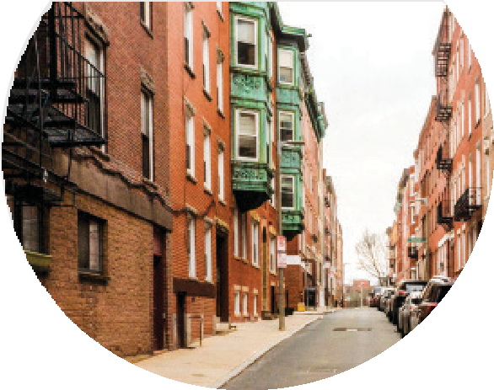
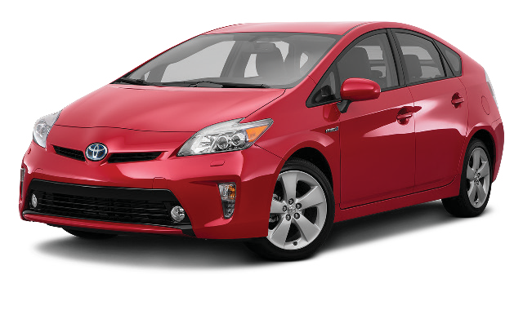

Information on the GOGOGRANDPARENT
Pilot Program here on Martha’s Vineyard for Older Adults (July, 2021)

WHAT’S GOGOGRANDPARENT?
An organization to help Older Adults get to where they want to go. GoGoGrandparent started because a grandma told her grandson that she was afraid of driving at night.
They request affordable Lyft and Uber rides on your behalf.

WHAT DO I NEED?
Any phone that can call 1 (855) 464-6872. You don’t need a “smart” phone or any apps. Hit “0” to speak to an operator to schedule your ride.

WHO ARE THE DRIVERS?
GoGoGrandparent works with Uber & Lyft to ensure that you can get affordable rides when you need them. Your trips are protected by Uber & Lyft’s insurance policies from when you get matched with a driver until you arrive at your destination.

WHO DO I GIVE MY DESTINATION TO?
To the Operator that you are speaking with. They will share that information with the driver.

CAN I BRING MY WALKER?
If you can get into a car without assistance from the driver, then walkers and foldable wheelchairs are no problem. If you use an assistive device, speak to an operator before ordering your ride so we can notate your account. You can bring along someone to help you as well, there is no additional charge.

WHEN CAN I CALL AN OPERATOR?
Operators are available 24/7 to schedule rides in advance and answer any questions that you have. Call and Press 0 to speak with an operator.

HOW DO I HANDLE PAYMENT TO MY DRIVER?

Your ride will pre-paid by HAMV, including tip, so there is no expectation that you will need to discuss or pay for anything.

HOW ELSE CAN I REACH OUT TO IF I STILL HAVE QUESTIONS OR CONCERNS?

You can call GOGOGRANDPARENT and talk with an Operator or your Council on Aging contact or Cindy Trish at HAMV (508) 693-7900 ext. 455

